
MEDUNO Healthcare
A Uno Healthcare Inc. USA Group Company
Global Pharmaceutical Export Partner
Oncology | Cardiology | Specialty Medicines

MEDUNO HEALTHCARE INDIA PRIVATE LIMITED
Global Pharmaceutical Export & Distribution Partner
Company Overview
Meduno Healthcare India Pvt. Ltd. is an India-based pharmaceutical merchant exporter specializing in Oncology, Cardiology, and Specialty pharmaceutical products. As part of the Uno Healthcare Inc. USA Group, Meduno serves international markets with a strong focus on quality, compliance, andreliable global supply.
Therapy Focus
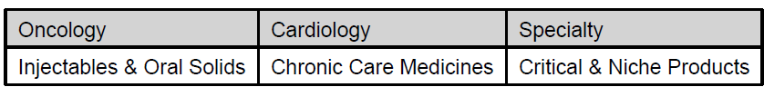
Product Portfolio –
Cardiology Products
Molecule | Strength | Dosage Form | Pack Size
Amlodipine | 5 mg / 10 mg | Tablet | 10 × 10
Telmisartan | 20 mg / 40 mg / 80 mg | Tablet | 10 × 10
Metoprolol | 25 mg / 50 mg | Tablet | 10 × 10
Atorvastatin | 10 mg / 20 mg | Tablet | 10 × 10
Rosuvastatin | 5 mg / 10 mg | Tablet | 10 × 10
Oncology Products
Molecule | Strength | Dosage Form | Pack Size
Tetrabenazine | 25 mg | Tablet | 10 × 10
Imatinib | 100 mg / 400 mg | Tablet | 10 × 10
Capecitabine | 500 mg | Tablet | 10 × 10
Temozolomide | 100 mg / 250 mg | Capsule | 5 × 5
Erlotinib | 100 mg / 150 mg | Tablet | 10 × 10
Specialty & Critical Care Products
Molecule | Strength | Dosage Form | Pack Size
Thymopentin | 10 mg | Injection | Vial
Diazoxide | 25 mg | Capsule | 10 × 10
Human Albumin | 20% | Injection | 50 ml
Filgrastim | 300 mcg | Injection | Prefilled Syringe
Catalog Disclaimer
Product availability, strengths, and packaging may vary based on destination country regulatory requirements. Detailed dossiers and specifications are available upon request.
Export Capabilities
- WHO-GMP compliant sourcing
- Cold chain & temperature-controlled logistics
- Export documentation & regulatory support
- Global freight & warehousing coordination
Markets Served
Africa | CIS | Middle East | South-East Asia | LATAM
Partners & Manufacturers
- Approved Manufacturing Partners
- Compliance Standards
Contact Details
Meduno Healthcare India Pvt. Ltd.
📍 India
📧 Email: info@meduno.in / vikas@meduno.in
📞 Phone: +91-9220917124
🌐 Website: www.meduno.in

